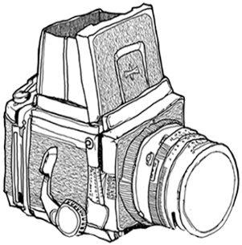

**José Luis Serrano Fotografía**

**JOSE LUIS SERRANO BARRERA**

**NIF: 50430076T**

**C/VITORIA, 11 6ºA**

**28941 FUENLABRADA**

**MADRID**

**DATOS DEL CLIENTE**

|  |
| --- |
|  |

**DATOS DEL PEDIDO**

|  |
| --- |
|  |

**DETALLE**

|  |  |  |  |
| --- | --- | --- | --- |
| **SERVICIO** | **IMPORTE UNITARIO** | **UNIDADES** | **IMPORTE TOTAL** |

|  |  |  |
| --- | --- | --- |
|  | ***Base Imponible*** |  |
|  | ***Descuento*** |  |
|  | ***Total*** |  |
|  | ***A cuenta*** |  |
|  | ***Resto*** |  |